Q1.

mysql> select orders.OrderID,orders.OrderDate,customers.Firstname,customers.Lastname

from orders

join customers on orders.CustomerID=customers.CustomerID;



Q2.

mysql> select products.Productname,(orderdetails.Quantity\*products.Price) AS TOTALREVENUE

from orderdetails

join products on orderdetails.ProductID=products.ProductID;

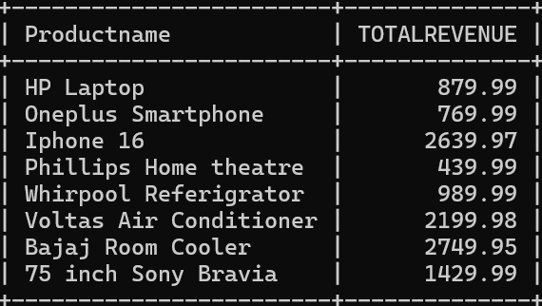

Q3.

mysql> SELECT customers.Firstname, customers.Lastname, customers.Email, customers.Phone

from customers

join orders on orders.CustomerID=customers.CustomerID;



Q4.

mysql> SELECT products.Productname, (orderdetails.Quantity) AS TotalQuantity

FROM orderdetails

JOIN products ON orderdetails.ProductID = products.ProductID

ORDER BY TotalQuantity DESC;

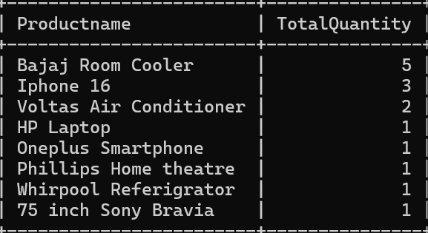

Q6.

SELECT customers.FirstName, customers.LastName, AVG(orders.TotalAmount) AS AverageOrderValue

FROM orders

JOIN customers ON orders.CustomerID = customers.CustomerID

GROUP BY customers.CustomerID;

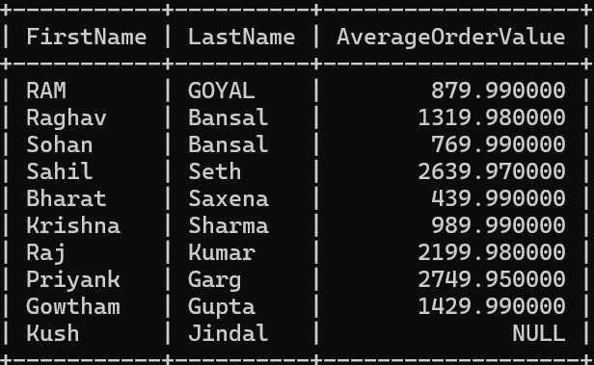

Q7.

SELECT orders.OrderID, customers.FirstName, customers.LastName, orders.TotalAmount

FROM orders

JOIN customers ON orders.CustomerID = customers.CustomerID

ORDER BY orders.TotalAmount DESC

LIMIT 1;

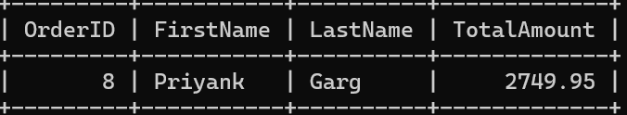

Q8.

mysql> select products.Productname, orderdetails.Quantity as QuantityOrdered

from orderdetails

join products on orderdetails.ProductID=products.ProductID;

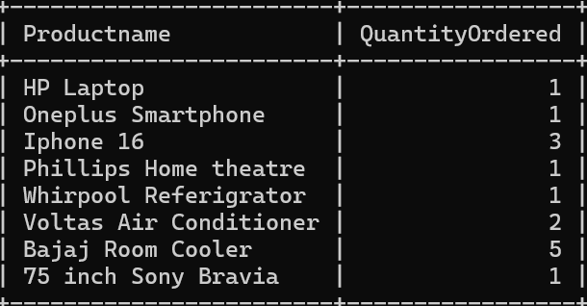

Q9.

mysql> SELECT customers.FirstName, customers.LastName

FROM orders

JOIN customers ON orders.CustomerID = customers.CustomerID

JOIN orderdetails ON orders.OrderID = orderdetails.OrderID

JOIN products ON orderdetails.ProductID = products.ProductID

WHERE products.ProductName ='Iphone 16';



Q10.

mysql> SELECT SUM(TotalAmount) AS TotalRevenue

FROM orders

WHERE OrderDate BETWEEN '2024-03-04' AND '2024-03-16';

